**Name: REEFSTORE**

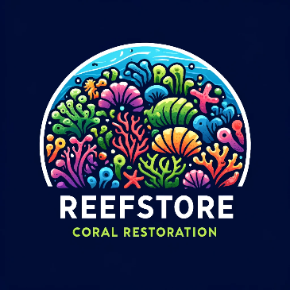Stage 1: A website – OUR SERVICES WILL BE IN MEXICO

Home Page Tab – below our services:

* + One education income stream – partnership with certifications – offer science restorations videos to certification companies - Cecilia
  + Traditional tours - <https://www.coralrestoration.org/dive-programs>Traditional tours - <https://www.coralrestoration.org/dive-programs> - Carina
  + Biodiversity credits - Valentina

Investors Tab – Explain seed capital and other financing needed. - Max

Partnerships Tab – Maite

**Education (income stream)**

Welcome to Reefstore Restoration Education!

**Our Mission**

At [OUR NAME] Restoration Education, we are dedicated to preserving and revitalizing one of the planet’s most vital ecosystems: coral reefs. Our mission is to provide comprehensive education and resources to individuals, communities, and organizations committed to restoring these underwater treasures.

**Why Coral Reefs Matter**

Coral reefs are the rainforests of the sea, teeming with diverse marine life. They play a crucial role in the health of our oceans and the planet by:

* Supporting over 25% of all marine species.
* Protecting coastal regions from erosion and storm surge.
* Providing food and income for millions of people.
* Offering potential medical discoveries.

**The Challenges**

Despite their importance, coral reefs are under threat from climate change, pollution, overfishing, and destructive human activities. These stressors lead to coral bleaching, disease, and ultimately the degradation of reef ecosystems. Immediate action is needed to restore and protect these natural wonders.

### **Science Restoration Videos to Certify Your Company**

#### **Elevate Your Company Biodiversity with Expert-Led Coral Reef Restoration Videos**

At Coral Reef Restoration Education, we offer high-quality, scientifically-backed video content designed to enhance certification programs in marine biology, environmental science, and conservation. Our videos provide in-depth knowledge and practical skills essential for understanding and implementing coral reef restoration projects.

#### **Video Content Offerings**

1. **Introduction to Coral Reef Ecosystems**
   * Overview of coral reef biology and ecology.
   * Importance of coral reefs to marine life and human communities.
   * Current threats to coral reefs and their global impact.
2. **Coral Reef Restoration Techniques**
   * Detailed explanations of various restoration methods:
     + **Coral Gardening:** Steps to cultivate and transplant corals.
     + **Artificial Reefs:** Design and implementation of man-made reef structures.
     + **Coral Propagation:** Techniques for fragmenting and growing corals.
     + **Microfragmentation:** Cutting-edge methods to accelerate coral growth.
   * Case studies showcasing successful restoration projects.
3. **Fieldwork and Monitoring**
   * Practical skills for conducting field surveys and monitoring coral health.
   * Techniques for assessing coral reef recovery and biodiversity.
   * Data collection and analysis methods.
4. **Sustainable Practices and Community Engagement**
   * Best practices for minimizing human impact on coral reefs.
   * Strategies for engaging local communities in conservation efforts.
   * Sustainable tourism guidelines to protect reef ecosystems.

#### **Benefits of the Certification**

* **Enhance Learning Outcomes:** Our videos provide comprehensive, up-to-date information from leading experts, ensuring your certification programs are robust and credible.
* **Flexible Integration:** Easily incorporate our video content into your existing curriculum or use them as standalone modules.
* **Engaging and Interactive:** High-quality visuals and clear explanations make complex scientific concepts accessible and engaging for learners.
* **Support Continuing Education:** Offer advanced training for professionals seeking to expand their knowledge and skills in coral reef restoration.

#### **How to Collaborate**

**Customized Solutions:** We can tailor our video content to meet the specific needs of your certification programs, ensuring alignment with your educational goals.

**Subscription Packages:** Choose from a range of subscription options to access our full library of videos, including regular updates and new releases.

**Exclusive Access:** Provide your learners with exclusive access to cutting-edge restoration techniques and the latest scientific research.

#### **Get Started**

Enhance your certification programs today with our expert-led coral reef restoration videos. Contact us to learn more about our offerings, customization options, and pricing.

**Email:** [partnerships@coralreefrestoration.org](mailto:partnerships@coralreefrestoration.org)**Phone:** +1 (123) 456-7890

**Together, we can educate and empower the next generation of marine conservationists.**

**Our Partnerships**

### **SSI and PADI**

We are excited to announce a strategic partnership with two of the world’s leading scuba diving certification agencies, SSI (Scuba Schools International) and PADI (Professional Association of Diving Instructors). These prestigious organizations have collectively certified over 34 million divers worldwide, underscoring their unparalleled influence and reach within the global diving community.

Our collaboration with SSI and PADI will introduce an optional comprehensive coral reef awareness education into their certification programs. This initiative aims to empower new divers with the knowledge needed to protect and preserve our vital marine ecosystems. Additionally, we will offer a specialized course designed for individuals aspiring to become active participants in coral reef restoration.

Revenues generated from the optional coral reef awareness section in the existing certifications and the new specialized restoration course will directly support our organization. These funds will enable us to maintain our operations, expand our reach to more coral reefs, and extend our conservation efforts to new countries. By integrating this critical environmental education into the certification process, we will foster a new generation of divers who are not only skilled in diving but also committed stewards of our oceans. This partnership aligns with our mission to promote sustainable diving practices and marine conservation on a global scale.

### **Local Diving School Collaboration**

We have an extensive and growing collaboration with local diving schools to promote our educational content and raise awareness about the importance of maintaining and restoring ocean health. These partnerships are instrumental in reaching more divers and spreading the message of conservation.

Through these local collaborations, we will organize specialized trips focused on coral reef restoration, providing hands-on experience and education to divers. This approach not only enhances the divers' skills but also directly contributes to the health of our oceans. By working closely with local diving schools, we ensure that our efforts to protect and restore coral reefs are widespread and impactful, ultimately fostering a community of informed and engaged ocean stewards.

### **Local Authorities**

### We also work closely with local authorities to ensure the maintenance and protection of the restored areas and to expand the dimensions of natural protected areas. Our partnership with local governments helps to enforce practices of responsible tourism and sustainable environmental management. By collaborating with authorities, we aim to secure long-term conservation outcomes and promote policies that enhance the resilience of marine ecosystems. This joint effort is crucial for creating a sustainable framework that supports both environmental preservation and community benefits, ensuring that restored areas continue to thrive and contribute to the overall health of our oceans.

### **Verra Certification for Carbon Credits**

To ensure our carbon credits are trustworthy, transparent, and robust, we will work with Verra, a leading standard-setting organization. Verra's Verified Carbon Standard (VCS) program is globally recognized for its rigorous validation and verification processes. By partnering with Verra, we guarantee that our carbon credits meet the highest standards of quality and integrity, providing confidence to buyers and stakeholders in the efficacy and impact of our conservation efforts. This collaboration will enhance our credibility and ensure the success of our blue carbon projects, contributing to our overarching mission of marine conservation and climate mitigation.

**Investors**

***Join Us in Restoring Mexico’s Coral Reefs!***

*Our mission is to rehabilitate Mexico’s vital coral reefs through innovative restoration techniques and sustainable business models. We collaborate with local authorities, marine biologists, and community stakeholders to ensure the longevity and health of these essential ecosystems. Your investment can help us turn this vision into reality.*

**Seed Capital and Financing Requirements**

To kickstart our coral reef restoration projects, we require significant seed capital. This initial funding is crucial to cover the costs of research, planning, and the initial phases of reef restoration. Based on similar successful projects globally, we estimate the following funding needs:

**Initial Funding Breakdown**:

*Research and Development: $200,000*

• Baseline surveys

• Genetic studies

• Environmental impact assessments

*Restoration Infrastructure: $500,000*

• Construction of coral nurseries

• Reef structure materials

• Specialized equipment and technology

*Operational Costs: $300,000*

• Salaries for marine biologists and divers

• Training programs for local communities

• Transportation and logistics

*Monitoring and Maintenance: $100,000*

• Long-term monitoring systems

• Regular maintenance of restored reefs

• Data collection and analysis

**Total Initial Investment Needed: $1.1 million**

**Financing Options**

We understand that a successful project requires diverse and sustainable financing streams. Here are the primary financing options we offer for investors:

**1. Equity Investment**

By investing equity, you become a part-owner of our company, sharing in both the risks and rewards of our venture. Equity investments provide the capital needed for large-scale restoration projects and offer potential returns through company growth and profitability.

**2. Debt Financing**

We offer structured debt financing options with competitive interest rates and clear repayment schedules. This allows investors to support our projects while receiving regular interest payments.

**3. Grants and Donations**

Non-profit organizations, foundations, and individual philanthropists can support our mission through grants and donations. These funds are crucial for specific projects or for covering unforeseen expenses.

**4. Reef Credits**

Similar to carbon credits, reef credits represent a quantified positive environmental impact. By purchasing reef credits, investors can directly support the restoration of coral reefs and potentially benefit from future trading of these credits as the market develops.

**5. Revenue Sharing**

Invest in our revenue-generating activities such as eco-tourism, diving expeditions, and educational programs. Revenue-sharing agreements provide a steady income stream while promoting sustainable tourism and local economic growth.

**Expected Returns on Investment**

Investing in coral reef restoration not only yields environmental benefits but also offers attractive financial returns. Here’s what investors can expect:

• Environmental Impact: Contribute to the recovery of coral reefs, enhance biodiversity, and improve coastal resilience against climate change.

• Economic Returns: Generate revenue through eco-tourism, diving, and educational activities. Investors benefit from revenue-sharing agreements and the potential appreciation of reef credits.

• Social Benefits: Support local communities by creating jobs, providing training, and fostering sustainable economic development.

**Join Our Mission Now!!!**

By investing in our coral reef restoration projects, you are contributing to a sustainable future for Mexico’s marine ecosystems. Together, we can create thriving coral reefs that support biodiversity, bolster local economies, and combat the adverse effects of climate change.

For more information on investment opportunities and how you can be part of this transformative journey, please contact our investment team.

**Biodiversity Credits**

**What Are Biodiversity Credits?**

Biodiversity credits are an innovative financial instrument designed to promote the conservation and restoration of natural ecosystems. These credits represent the quantified positive impact on biodiversity resulting from specific conservation actions, such as coral reef restoration projects. By purchasing biodiversity credits, companies and individuals can contribute directly to preserving biodiversity and mitigating environmental impacts.

**Why are they important?**

Biodiversity credits play a crucial role in conservation efforts by providing a sustainable funding mechanism for long-term environmental projects. They enable businesses to demonstrate their commitment to achieve Nature-positive outcomes. In addition, biodiversity credits help raise awareness about the importance of conserving vital ecosystems like coral reefs, which are essential for maintaining marine biodiversity, supporting fisheries, and protecting coastal communities from storm surges.

**How It Works:**

1. **Project Development**: Our coral reef restoration projects are strategically located in Mexico, chosen for their high biodiversity value and ecological significance. Each project begins with thorough research and planning to ensure maximum impact.
2. **Credit Issuance**: As restoration progresses, we issue biodiversity credits based on the measurable improvements in the health and diversity of the coral reefs, as well as the increasing number of species found in the habitat. The credits are verified by independent third parties to ensure transparency and credibility.
3. **Purchase and Investment**: Businesses looking to become Nature-positive are encouraged to purchase our biodiversity credits. The funds from the sales are directly reinvested into our ongoing and future restoration projects, creating a sustainable financing loop, and scaling the environmental impact.
4. **Impact Reporting**: Buyers of our biodiversity credits will receive detailed reports on the ecological impact of their investment. The reports include metrics on biodiversity enhancement, coral health, and the broader benefits to marine life and local communities.
5. **Long-Term Benefits**: By investing in biodiversity credits, companies can not only offset their environmental footprint but also contribute to the resilience of vital ecosystems. This investment helps protect biodiversity, supports local economies, and promotes global environmental health.

By participating in this innovative approach to conservation, businesses can align their sustainability goals with tangible environmental outcomes, fostering a healthier planet for future generations.

**How much do the credits cost?**

We believe in transparency and simplicity when it comes to pricing our biodiversity credits. Our pricing structure is designed to reflect the true value of the positive environmental impact your investment will generate.

**Biodiversity Credit Price**: $50 per credit

Each biodiversity credit represents the restoration and protection of a specific area of coral reef, verified by independent third parties. The funds generated from the sale of these credits are directly reinvested into our coral reef restoration projects in Mexico, ensuring long-term sustainability and environmental impact.

**Volume Discounts**: For large-scale investments, we offer volume discounts:

* + 100-499 credits: $48 per credit
  + 500-999 credits: $45 per credit
  + 1000+ credits: $42 per credit

**What You Get**

* **Impact Reports**: Detailed reports on the positive impact of your investment, including metrics on biodiversity enhancement, coral health, and benefits to marine life and local communities.
* **Certification**: A certificate acknowledging your contribution to coral reef restoration, suitable for display in your office or for use in sustainability reports.

Join us in making a meaningful impact on the environment by purchasing biodiversity credits today. For more information or to make a purchase, please [Contact Us](https://chatgpt.com/c/bcdcf959-7ac7-4085-bb23-1660e544e3b9).

**Traditional tour**

**Intro** (optional, or can be used in other parts)

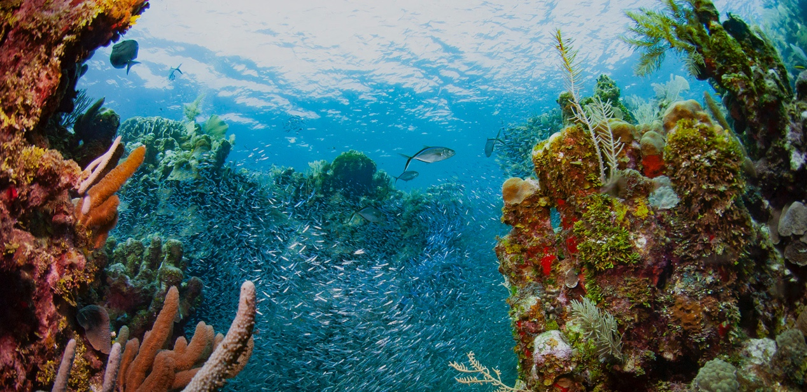

In recent years, the Mexican government and environmental organizations have increased their efforts to protect coral reefs and have implemented a series of measures to preserve and restore coral reef ecosystems. At the same time, Mexico has gradually opened up coral reef areas, allowing for eco-tourism and scientific research activities in these regions. This provides a good development opportunity for the eco-tourism industry and brings more support and attention to coral reef conservation.

Our eco-tourism project is developed in this context, aiming to promote awareness and support for coral reef conservation by providing high-quality eco-tourism experiences. We collaborate with local coral nurseries, dedicated to protecting and restoring coral reef ecosystems, offering visitors the opportunity to participate in coral conservation activities and gain in-depth understanding of coral conservation efforts.

Through our eco-tourism project, visitors can not only admire the magnificent coral reef landscapes but also learn about the importance of coral reefs and our individual responsibility towards their protection. This is our mission and vision: to advance environmental conservation through tourism, contributing to coral reef protection and biodiversity conservation.

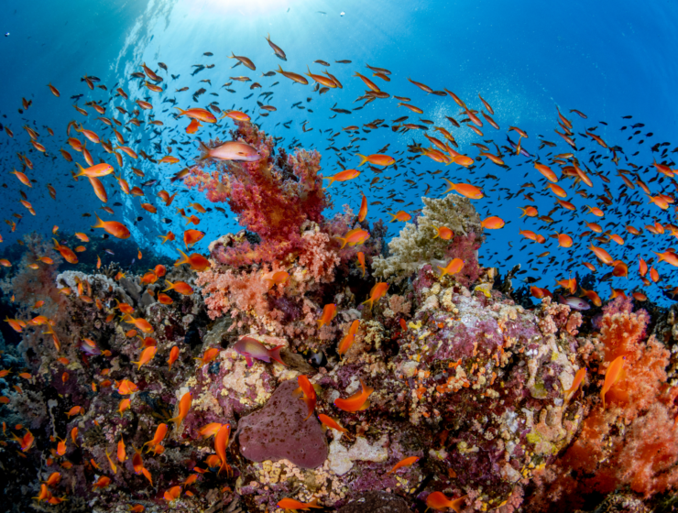

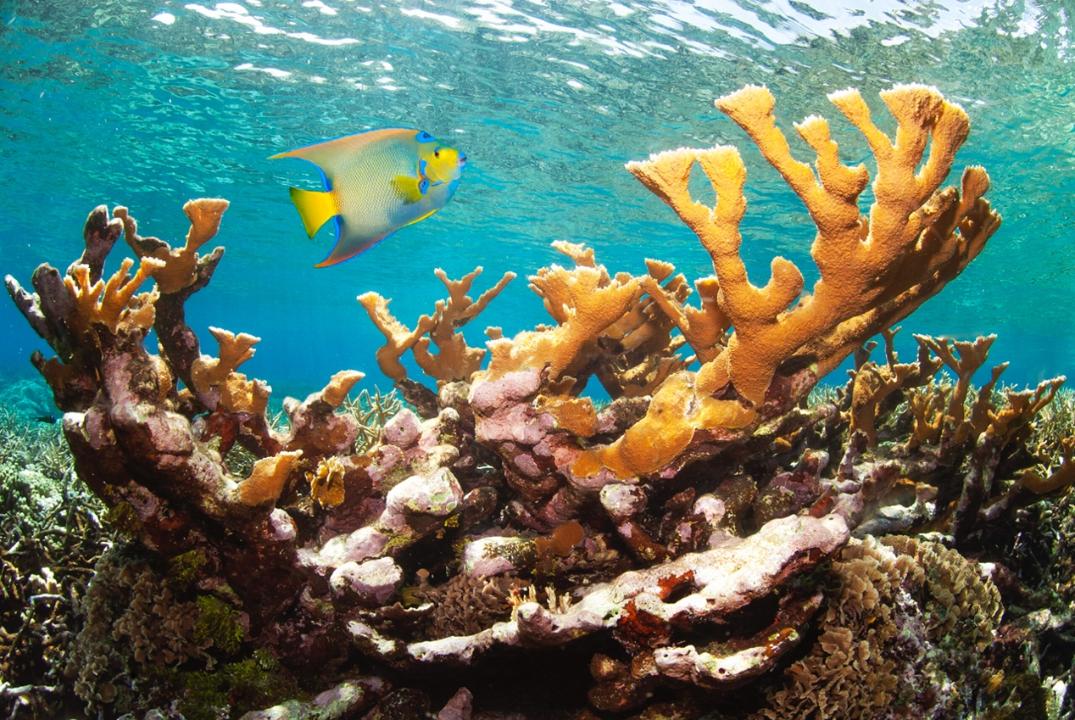

**Our mission and vision:**

Mission: "Protecting Coral Reefs, Enhancing Biodiversity – One Eco-Tour at a Time."

Vision: "Leading the Way in Coral Reef Eco-Tourism – Innovation, Collaboration, Conservation."

 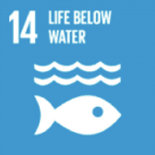 our work and SDGs

**Tourism routes：**

Our services focus on the reef in Mexico.

1. Oaxaca, Huatulco: the most important coral reefs on the Mexican Pacific coast.

2. Yucatan Peninsula and Quintana Roo, Puerto Morelos Reef National Park: part of the Mesoamerican Reef System, the second largest in the world and the largest in Mexico.

3. Baja California, Cabo Pulmo National Park: the only coral reef in the Gulf of California and the oldest reef on the American Pacific coast.

4. Bahía, La Paz: reefs create refuge zones for the local ecosystem.

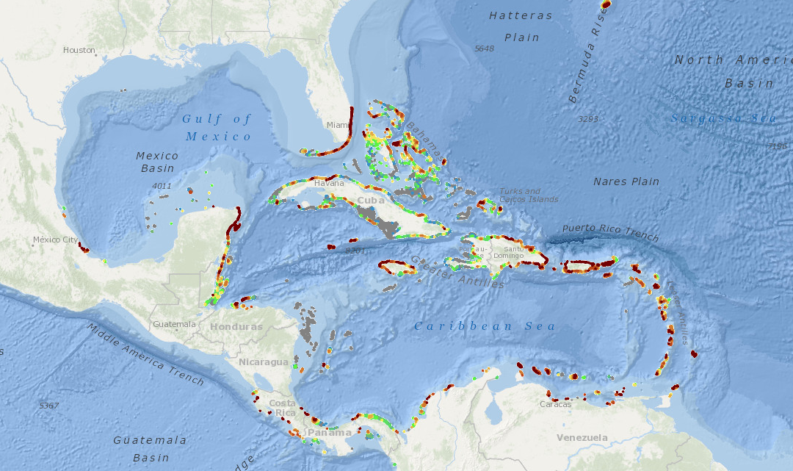

Tourism options



**a. Traditional Diving + Coral Viewing:**

This option is our basic service, providing visitors with the opportunity to explore the beauty of coral reefs. Guided by experienced local divers, visitors will dive and tour coral reef attractions, learning about their ecosystems and the importance of coral conservation. This service is ideal for visitors who want to easily experience the beauty of coral reefs.

Suggested Fee: $60 per person

Fee Justification:

Costs of providing diving equipment and guiding divers;

Fees for professional tour guides and coral viewing;

Donations for coral conservation and environmental protection.

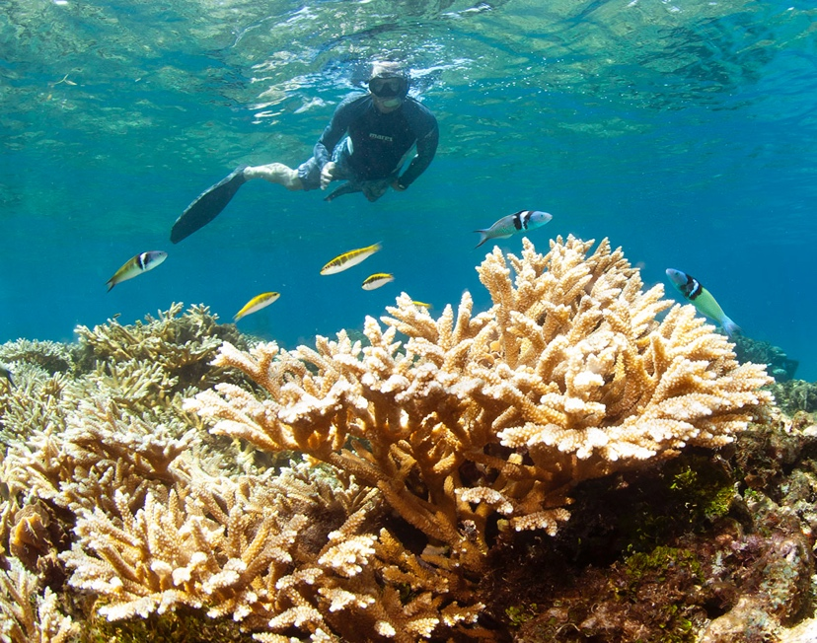

**b. Coral Nursery Visit + Traditional Diving + Coral Viewing:**

This option is our value-added service. In collaboration with the local coral nursery organization CORALISMA, visitors will have the opportunity to visit a coral nursery, learn about coral cultivation and conservation efforts, and participate in coral protection activities. This option not only offers the experience of traditional diving and coral viewing but also allows visitors to gain a deeper understanding of the significance and methods of coral conservation.

Suggested Fee: $80 per person

Fee Justification:

Costs associated with collaborating with the coral nursery organization, including tour and participation fees for conservation activities;

Costs of providing diving equipment and guiding divers;

Fees for professional tour guides and coral viewing;

Donations for coral conservation and environmental protection.

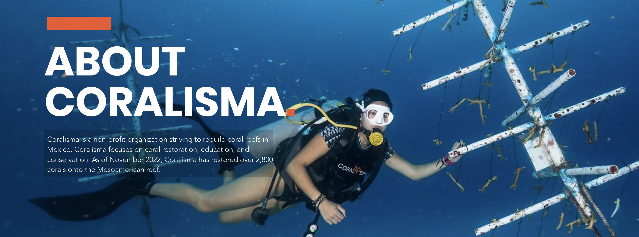

**c. Coral Replanting：**

This is our public welfare cooperation project, designed for divers with certification and years of diving experience. In collaboration with the local coral nursery base 'CORALISMA,' this project offers trainees the opportunity to learn and train in coral nursery and replanting, with a training period of about one month. Trainees will learn how to protect and cultivate corals and then participate in actual coral replanting work. This project provides a unique coral conservation experience and is a positive contribution to environmental protection efforts.

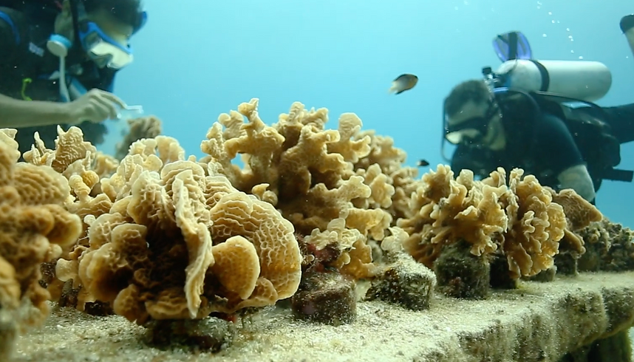Suggested Fee: ### per person (training fee)

Fee Justification:

Costs of providing learning and training in coral nursery and replanting;

Training period of about one month, requiring payment for trainers, equipment, and venues;

Training fees serve as funds for the base, supporting coral conservation and environmental protection efforts.

Ref：

<https://www.distantjourneys.co.uk/great-barrier-reef-guided-snorkel-tour/>

<https://www.coralisma.com/services-4>

<https://www.coralrestoration.org/citizen-science-collaborations>

<https://rutopia.com/en/blog/coral-reefs-in-mexico-biological-treasure>